**Quickstart: Deploy an ASP.NET web app**

* Article
* 12/17/2021
* 15 minutes to read
  + [](https://github.com/cephalin)
  + [](https://github.com/DavidCBerry13)
  + [](https://github.com/alexbuckgit)
  + [](https://github.com/mijacobs)
  + [](https://github.com/pritamso)
  + +12

Is this page helpful?

Top of Form

Choose a deployment environment

Visual StudioVisual Studio CodeAzure CLIAzure PowerShell

Bottom of Form

**In this article**

1. [Prerequisites](https://docs.microsoft.com/en-us/azure/app-service/quickstart-dotnetcore?tabs=net60&pivots=development-environment-vs#prerequisites)
2. [Create an ASP.NET web app](https://docs.microsoft.com/en-us/azure/app-service/quickstart-dotnetcore?tabs=net60&pivots=development-environment-vs#create-an-aspnet-web-app)
3. [Publish your web app](https://docs.microsoft.com/en-us/azure/app-service/quickstart-dotnetcore?tabs=net60&pivots=development-environment-vs#publish-your-web-app)
4. [Update the app and redeploy](https://docs.microsoft.com/en-us/azure/app-service/quickstart-dotnetcore?tabs=net60&pivots=development-environment-vs#update-the-app-and-redeploy)
5. [Manage the Azure app](https://docs.microsoft.com/en-us/azure/app-service/quickstart-dotnetcore?tabs=net60&pivots=development-environment-vs#manage-the-azure-app)
6. [Clean up resources](https://docs.microsoft.com/en-us/azure/app-service/quickstart-dotnetcore?tabs=net60&pivots=development-environment-vs#clean-up-resources)
7. [Next steps](https://docs.microsoft.com/en-us/azure/app-service/quickstart-dotnetcore?tabs=net60&pivots=development-environment-vs#next-steps)

In this quickstart, you'll learn how to create and deploy your first ASP.NET web app to [Azure App Service](https://docs.microsoft.com/en-us/azure/app-service/overview). App Service supports various versions of .NET apps, and provides a highly scalable, self-patching web hosting service. ASP.NET web apps are cross-platform and can be hosted on Linux or Windows. When you're finished, you'll have an Azure resource group consisting of an App Service hosting plan and an App Service with a deployed web application.

**Prerequisites**

* [.NET 6.0](https://docs.microsoft.com/en-us/azure/app-service/quickstart-dotnetcore?tabs=net60&pivots=development-environment-vs#tabpanel_1_net60)
* [.NET Framework 4.8](https://docs.microsoft.com/en-us/azure/app-service/quickstart-dotnetcore?tabs=net60&pivots=development-environment-vs#tabpanel_1_netframework48)
* An Azure account with an active subscription. [Create an account for free](https://azure.microsoft.com/free/dotnet).
* [Visual Studio 2022](https://www.visualstudio.com/downloads) with the **ASP.NET and web development** workload.

If you've already installed Visual Studio 2022:

1. Install the latest updates in Visual Studio by selecting **Help** > **Check for Updates**.
2. Add the workload by selecting **Tools** > **Get Tools and Features**.

**Create an ASP.NET web app**

* [.NET 6.0](https://docs.microsoft.com/en-us/azure/app-service/quickstart-dotnetcore?tabs=net60&pivots=development-environment-vs#tabpanel_5_net60)
* [.NET Framework 4.8](https://docs.microsoft.com/en-us/azure/app-service/quickstart-dotnetcore?tabs=net60&pivots=development-environment-vs#tabpanel_5_netframework48)

1. Open Visual Studio and then select **Create a new project**.
2. In **Create a new project**, find, and choose **ASP.NET Core Web App**, then select **Next**.
3. In **Configure your new project**, name the application *MyFirstAzureWebApp*, and then select **Next**.

[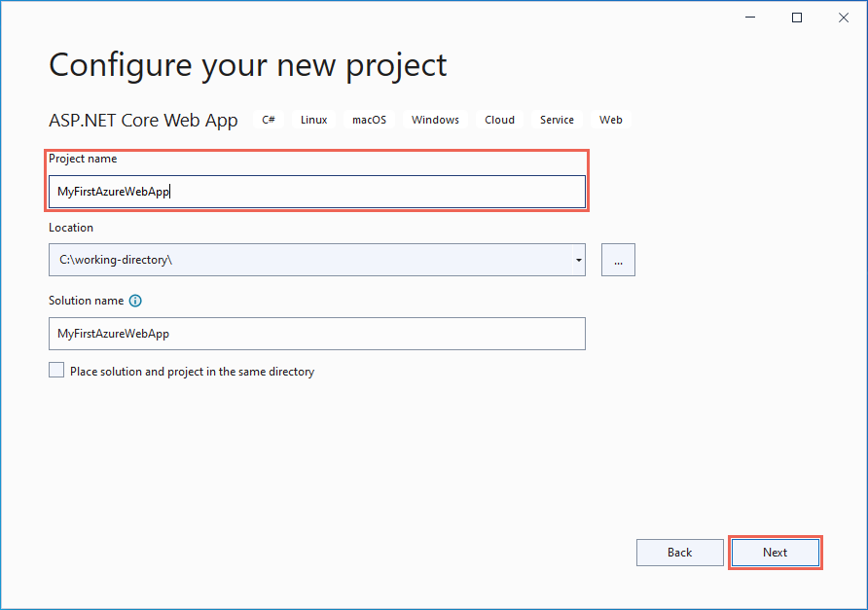](https://docs.microsoft.com/en-us/azure/app-service/media/quickstart-dotnet/configure-webapp-net.png#lightbox)

1. Select **.NET Core 6.0 (Long-term support)**.
2. Make sure **Authentication Type** is set to **None**. Select **Create**.

[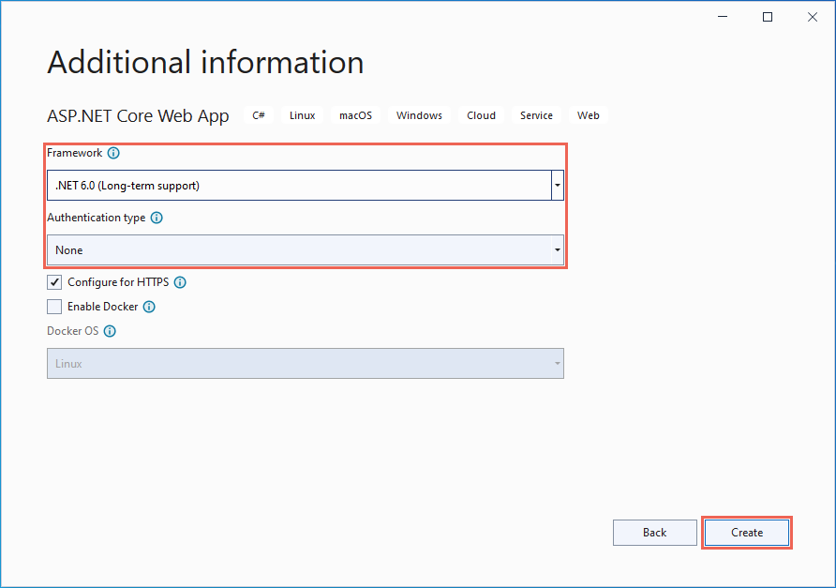](https://docs.microsoft.com/en-us/azure/app-service/media/quickstart-dotnet/vs-additional-info-net60.png#lightbox)

1. From the Visual Studio menu, select **Debug** > **Start Without Debugging** to run the web app locally.

[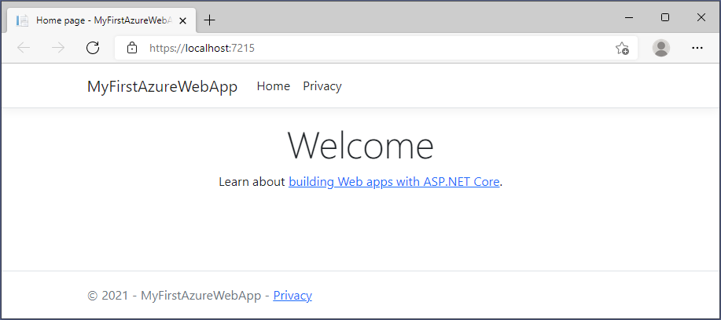](https://docs.microsoft.com/en-us/azure/app-service/media/quickstart-dotnet/local-webapp-net.png#lightbox)

**Publish your web app**

To publish your web app, you must first create and configure a new App Service that you can publish your app to.

As part of setting up the App Service, you'll create:

* A new [resource group](https://docs.microsoft.com/en-us/azure/azure-resource-manager/management/overview#terminology) to contain all of the Azure resources for the service.
* A new [Hosting Plan](https://docs.microsoft.com/en-us/azure/app-service/overview-hosting-plans) that specifies the location, size, and features of the web server farm that hosts your app.

Follow these steps to create your App Service resources and publish your project:

1. In **Solution Explorer**, right-click the **MyFirstAzureWebApp** project and select **Publish**.
2. In **Publish**, select **Azure** and then **Next**.

[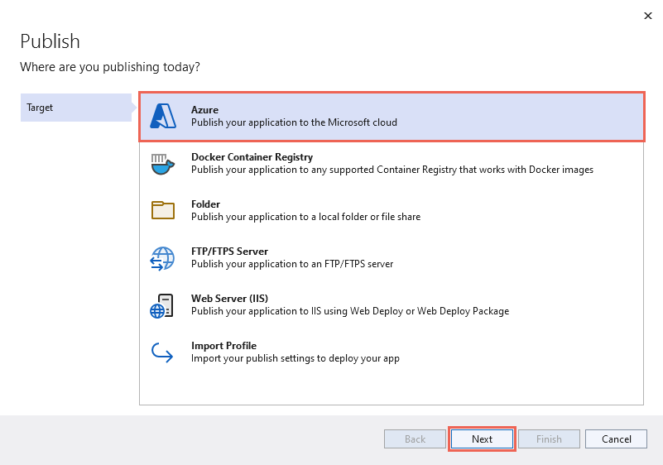](https://docs.microsoft.com/en-us/azure/app-service/media/quickstart-dotnet/vs-publish-target-azure.png#lightbox)

1. Choose the **Specific target**, either **Azure App Service (Linux)** or **Azure App Service (Windows)**. Then, click **Next**.

**Important**

When targeting ASP.NET Framework 4.8, use **Azure App Service (Windows)**.

1. Your options depend on whether you're signed in to Azure already and whether you have a Visual Studio account linked to an Azure account. Select either **Add an account** or **Sign in** to sign in to your Azure subscription. If you're already signed in, select the account you want.

[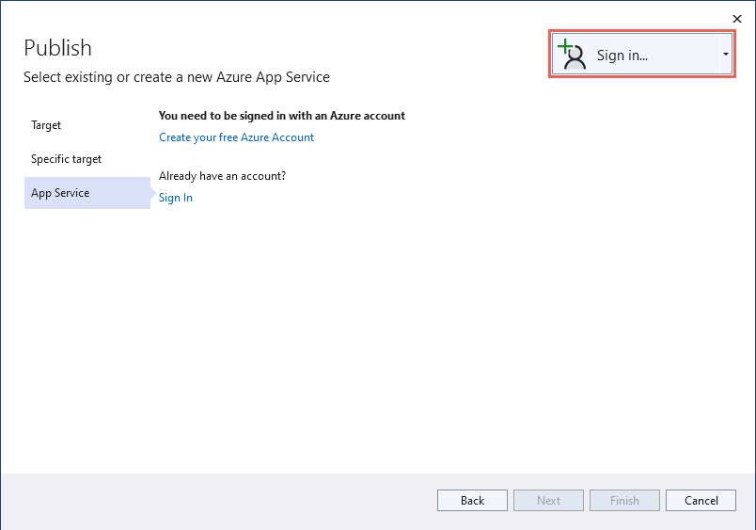](https://docs.microsoft.com/en-us/azure/app-service/media/quickstart-dotnet/sign-in-azure.png#lightbox)

1. To the right of **App Service instances**, select **+**.

[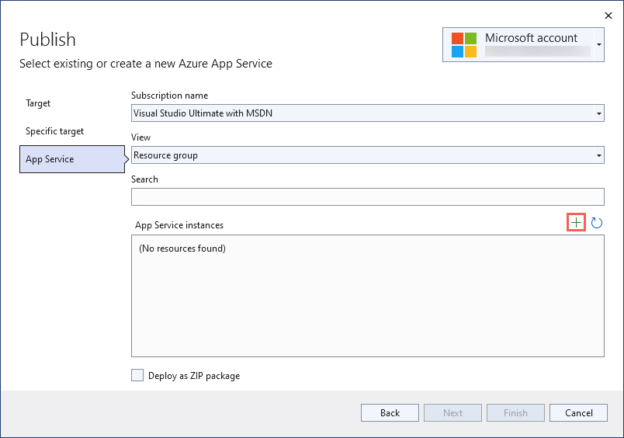](https://docs.microsoft.com/en-us/azure/app-service/media/quickstart-dotnet/publish-new-app-service.png#lightbox)

1. For **Subscription**, accept the subscription that is listed or select a new one from the drop-down list.
2. For **Resource group**, select **New**. In **New resource group name**, enter *myResourceGroup* and select **OK**.
3. For **Hosting Plan**, select **New**.
4. In the **Hosting Plan: Create new** dialog, enter the values specified in the following table:

| **TABLE 1** | | |
| --- | --- | --- |
| **Setting** | **Suggested value** | **Description** |
| **Hosting Plan** | *MyFirstAzureWebAppPlan* | Name of the App Service plan. |
| **Location** | *West Europe* | The datacenter where the web app is hosted. |
| **Size** | *Free* | [Pricing tier](https://azure.microsoft.com/pricing/details/app-service/?ref=microsoft.com&utm_source=microsoft.com&utm_medium=docs&utm_campaign=visualstudio) determines hosting features. |

1. [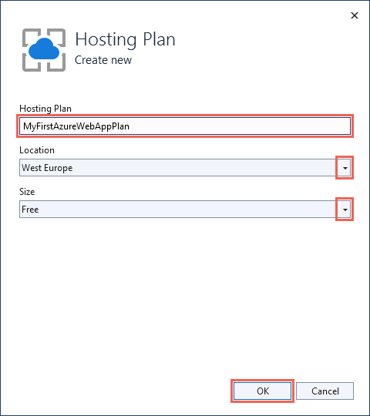](https://docs.microsoft.com/en-us/azure/app-service/media/quickstart-dotnet/create-new-hosting-plan.png#lightbox)
2. In **Name**, enter a unique app name that includes only the valid characters are a-z, A-Z, 0-9, and -. You can accept the automatically generated unique name. The URL of the web app is http://<app-name>.azurewebsites.net, where <app-name> is your app name.
3. Select **Create** to create the Azure resources.

[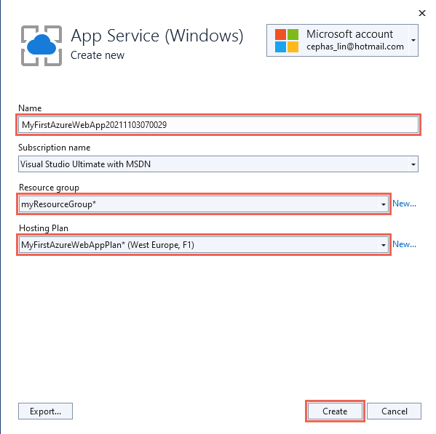](https://docs.microsoft.com/en-us/azure/app-service/media/quickstart-dotnet/web-app-name.png#lightbox)

Once the wizard completes, the Azure resources are created for you and you are ready to publish your ASP.NET Core project.

1. In the **Publish** dialog, make sure your new App Service app is selected in **App Service instance**, then select **Finish**. Visual Studio creates a publish profile for you for the selected App Service app.
2. In the **Publish** page, select **Publish**. If you see a warning message, click **Continue**.

Visual Studio builds, packages, and publishes the app to Azure, and then launches the app in the default browser.

* + [.NET 6.0](https://docs.microsoft.com/en-us/azure/app-service/quickstart-dotnetcore?tabs=net60&pivots=development-environment-vs#tabpanel_10_net60)
  + [.NET Framework 4.8](https://docs.microsoft.com/en-us/azure/app-service/quickstart-dotnetcore?tabs=net60&pivots=development-environment-vs#tabpanel_10_netframework48)

You'll see the ASP.NET Core 6.0 web app displayed in the page.

[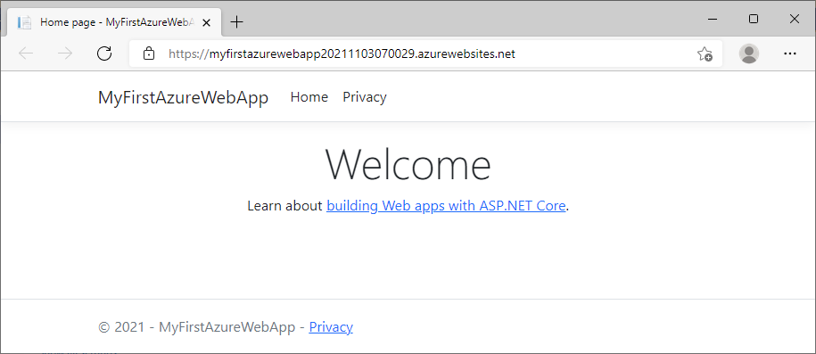](https://docs.microsoft.com/en-us/azure/app-service/media/quickstart-dotnet/azure-webapp-net.png#lightbox)

**Update the app and redeploy**

Follow these steps to update and redeploy your web app:

1. In **Solution Explorer**, under your project, open *Index.cshtml*.
2. Replace the first <div> element with the following code:

razorCopy

<div class="jumbotron">

<h1>.NET 💜 Azure</h1>

<p class="lead">Example .NET app to Azure App Service.</p>

</div>

Save your changes.

1. To redeploy to Azure, right-click the **MyFirstAzureWebApp** project in **Solution Explorer** and select **Publish**.
2. In the **Publish** summary page, select **Publish**.

When publishing completes, Visual Studio launches a browser to the URL of the web app.

* + [.NET 6.0](https://docs.microsoft.com/en-us/azure/app-service/quickstart-dotnetcore?tabs=net60&pivots=development-environment-vs#tabpanel_15_net60)
  + [.NET Framework 4.8](https://docs.microsoft.com/en-us/azure/app-service/quickstart-dotnetcore?tabs=net60&pivots=development-environment-vs#tabpanel_15_netframework48)

You'll see the updated ASP.NET Core 6.0 web app displayed in the page.

[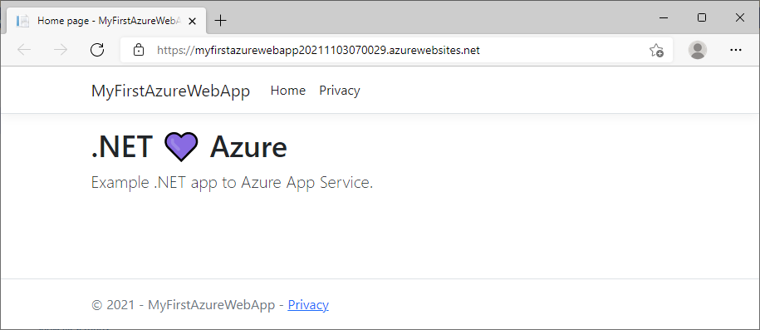](https://docs.microsoft.com/en-us/azure/app-service/media/quickstart-dotnet/updated-azure-webapp-net.png#lightbox)

**Manage the Azure app**

To manage your web app, go to the [Azure portal](https://portal.azure.com/), and search for and select **App Services**.

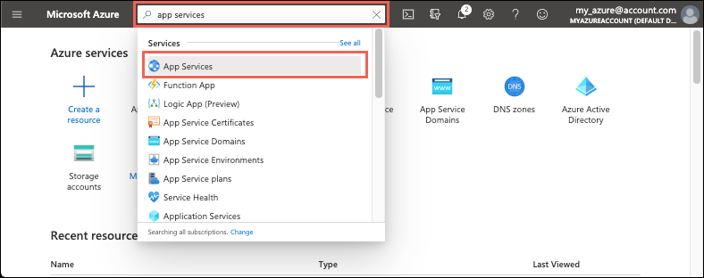

On the **App Services** page, select the name of your web app.

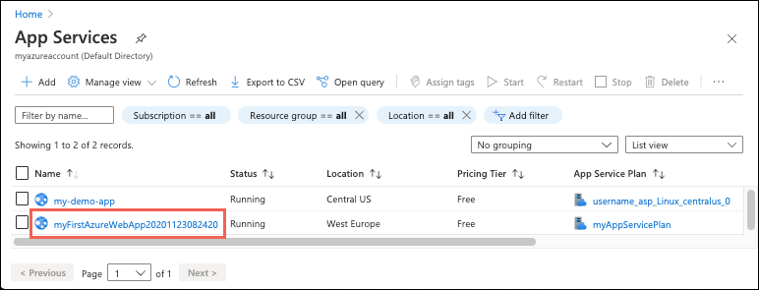

The **Overview** page for your web app, contains options for basic management like browse, stop, start, restart, and delete. The left menu provides further pages for configuring your app.

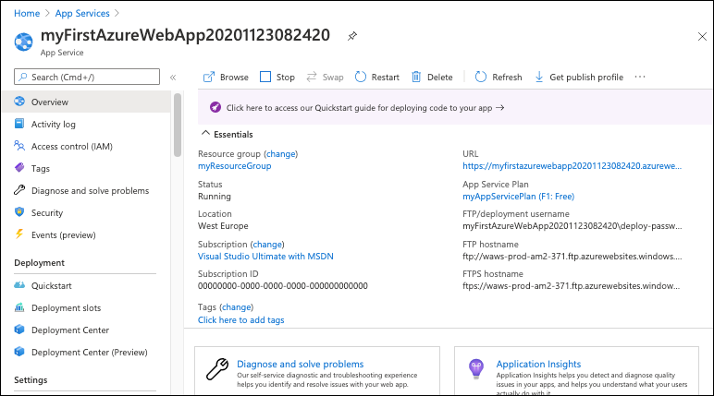

**Clean up resources**

In the preceding steps, you created Azure resources in a resource group. If you don't expect to need these resources in the future, you can delete them by deleting the resource group.

1. From your web app's **Overview** page in the Azure portal, select the **myResourceGroup** link under **Resource group**.
2. On the resource group page, make sure that the listed resources are the ones you want to delete.
3. Select **Delete**, type **myResourceGroup** in the text box, and then select **Delete**.